UNIVERSITY OF COMPUTER STUDIES (MANDALAY)


SECURE ONLINE VOTING SYSTEM
ADVANCED DATABASE
(CS-4225)

SUMITTED BY
GROUP-V
FOURTH YEAR (CS-SR)
2025-2026(ACEDEMIC YEAR)
Group Member List
No. RollNo Name
- KPTM_10994 Ma Theint Nadi Soe
- KPTM_10995 Ma Hay Mi Kyaw
- KPTM_10997 Ma Theint Thinzar Lwin
- KPTM-10996 Ma Thet Htar Swe
- KPTM-10993 Ma Pyae Theingi Kyaw
- KPTM-10998 Ma Chit Su Wai

Table of Contents
Abstract Page
1. Introduction 1

2. Objectives 2
3. Software Development Tool 3
4. Database Design 4
  - CRUX Matrix 4
  - Data Dictionary 5
  - ER Diagram 8
5. Implementation 9
6.Conclusion 20

Abstract
The Secure Online Voting System is a Windows-based application developed using Java to conduct elections in a secure and simple way. It allows administrators to manage voter details, candidate information, and election results. Voters can log in and cast their vote electronically. The system reduces paperwork, saves time, and improves accuracy. It also prevents duplicate voting and keeps data safe using security features. This application makes the voting process fast, reliable, and easy to use.

1. Introduction
Voting is an important activity in any organization. Traditional voting methods use paper and manual work, which can lead to errors, delays, and security issues. Managing voter records and counting votes manually requires a lot of effort.
The Voting Management System is a Windows-based Java application designed to overcome these problems. It provides a secure platform where voters can cast their votes electronically, and administrators can manage the election process easily. The system stores data safely and ensures that each voter can vote only once. It also helps in generating quick and accurate results.
This application is user-friendly, secure, and efficient. It reduces manual work and improves the overall voting process.

2. Objectives
The objectives of the Voting Management System are:
- To provide a secure electronic voting platform.
- To simplify voter and candidate registration processes.
- To prevent duplicate or unauthorized voting.
- To maintain accurate and tamper-proof election records.
- To allow administrators to easily manage election data and generate reports.
- To provide voters with a simple and user-friendly interface for voting.

3. Software Development Tool
3.1 Programming language: Java
Java is used as the main programming language to develop the voting system. It is a widely used object-oriented programming language that provides portability, security, and reliability.
In this project, Java Swing (JFrame) is used to design the graphical user interface (GUI). It allows the development of interactive windows such as login forms, candidate registration forms, voter lists, and voting panels. Java also provides strong database connectivity through JDBC, which enables communication between the application and the database.
3.2 Database: PostgreSQL
PostgreSQL is used as the backend database management system for storing and managing election data. It is a powerful open-source relational database known for its reliability, scalability, and performance.The Java application connects to PostgreSQL using JDBC (Java Database Connectivity) to perform operations such as inserting, updating, retrieving, and deleting records.
3.3 ER Master Plugin
The ER Master Plugin is used to design and manage the Entity Relationship (ER) Diagram. The ER diagram visually represents the database structure, including entities, attributes, and relationships between tables.
The ER Diagram is drawn using:
https://www.drawio.com

4. Database Design
  - CRUD Matrix
A CRUD Matrix is very useful for identifying the Data Items which are involved in the Data Access for each application. SQL consists of only 4 statements, sometimes referred to as CRUD:
- Create-INSERT- to store new data
- Read-SELECT-to retrieve data
- Update-UPDATE-To change or modify data
- Delete-DELETE- to delete data

CRUD Matrix for Secure Online Voting System
Entity | ADMIN | VOTER | SYSTEM
Admin | C,R,U | - | R (authentication during login)
addvoter1 | C,R, U (register/manage voters) | - | R (verify voter login)
partylist1 | C,R, U (register/manage candidates) | R (view candidate list) | R (display candidates during voting)
Result | R (view results) | C (cast vote) | C,R,U (count votes and generate results)

  - Data Dictionary – Voting_Management_System
Table Name | Field Name / Data Type | Description
  Constraints
admin |  | Admin username | Primary Key
  name – character varying
 |  |  | Not Null
  password – character varying
  Admin login password

Table4.2.1: admin

Table4.2.2: voter
Table Name | Field Name / Data Type | Description | Constraints
voter | voterid – character varying | Unique ID for voter | Primary Key, Not Null
 | password – character varying | Voter login password | Not Null
 | name – character varying | Name of the voter | Not Null
 | fathername – character varying | Father’s name of voter | Not Null
 | address – character varying | Residential address | —
 | sex – character varying | Gender of voter | —
 | age – integer | Age of voter | —
 | name |  | Foreign Key

Table4.2.3: candidate
Table Name | Field Name | Data Type | Description | Constraints
candidate | party_name | character varying | Name of the political party | Primary Key, Not Null
 | party_leader | character varying | Name of party leader | Not Null
 | sex | character varying | Gender of party leader | —
 | age | integer | Age of party leader | —
 | partyheadquarter | character varying | Head office location of party | —
 | partysign | character varying | Election symbol / party sign | Not Null
 | name | character varying | — | Foreign Key
 | voterid | character varying | — | Foreign Key

Table4.2.4: result
Table Name | Field Name | Data Type | Description | Constraints
Result | id | integer | Unique party/result ID | Primary Key
 | partyname | character varying | Name of political party | Not Null
 | count | integer | Number of votes received | Default 0
 | Party-name | character varying | _ | Foreign Key

4.3 ER Diagram for Secure Online Voting System
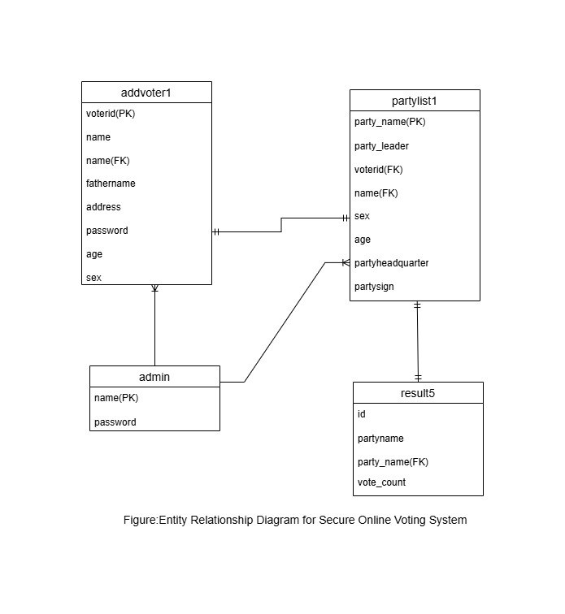

5.Implementation
5.1 Login
This page implements the login module of the Voting Management System, providing separate authentication interfaces for Admin and Voter. The Admin login allows authorized administrators to access system management functions using a username and password, while the Voter login verifies voter credentials using voter ID and password before allowing access to the voting process. Input validation and reset options are included to ensure secure and user-friendly authentication.
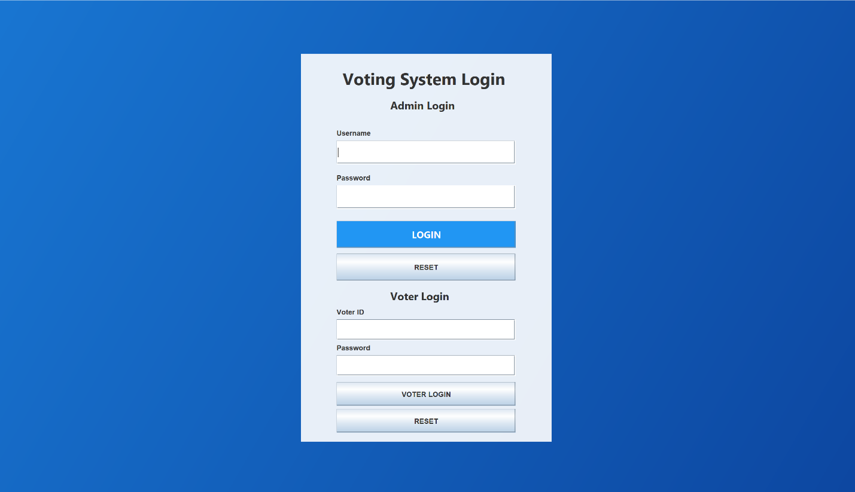
Fig 5.1 Login
5.2Admin home page
In the home page there are six options that only Admin can view, add voter, update voter, display voter list,add candidate,update candidate,display candidate list,counting and result.
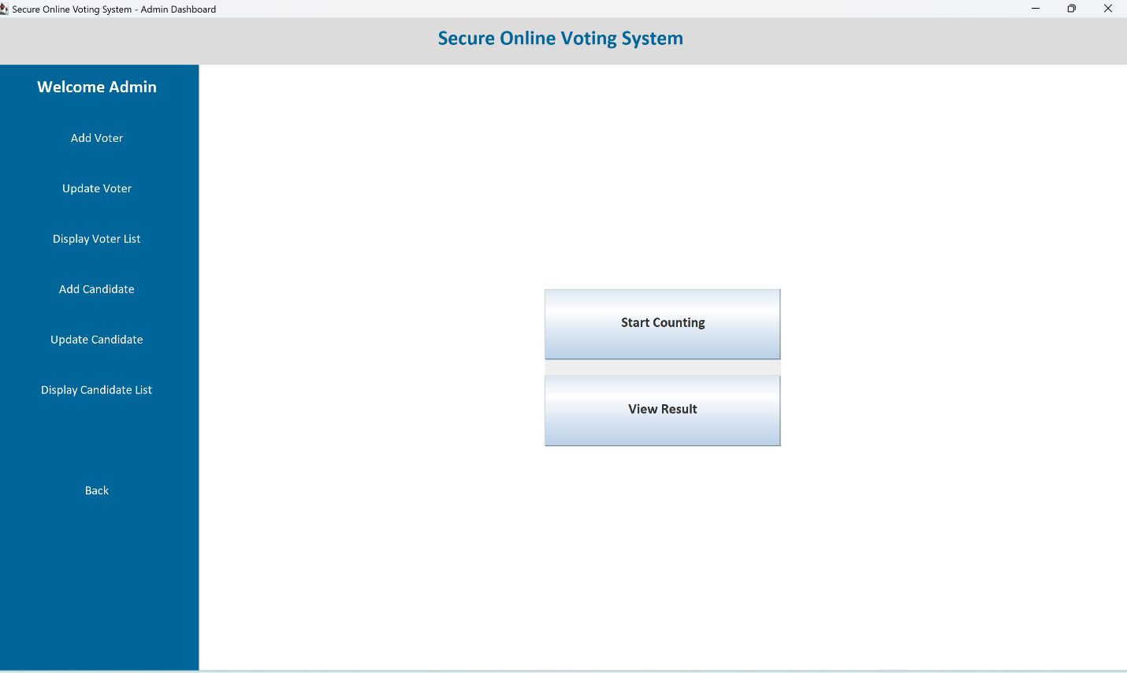

Fig 5.2Admin home page

5.3 Add voter
This page is used by the admin to add new voter details into the system.When the admin clicks “Add Voter” from the dashboard menu, they arrive at the Add Voter Page. This page shows a form with fields for Voter ID, Password, Father Name, Address, Sex, and Age. The admin fills in the details and clicks the “Add Voter” button. The system then saves the voter information in the database and shows a confirmation message. If any required field is missing or the Voter ID already exists, an error message appears
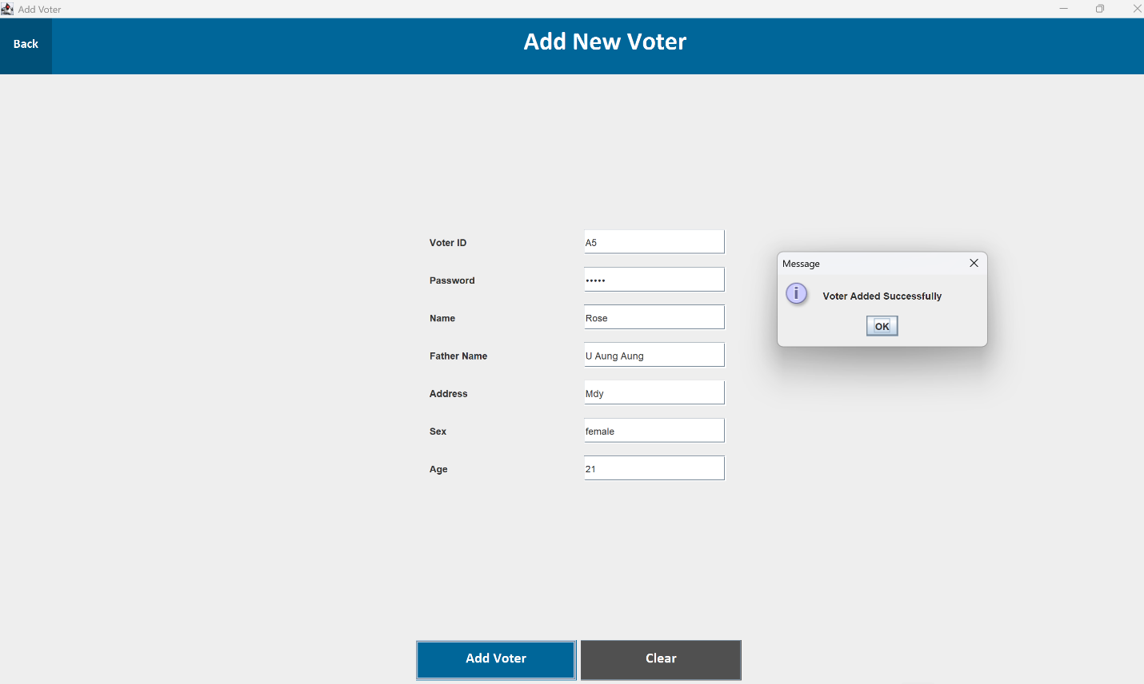

Fig 5.3 Add voter

5.4 Update Voter
This page is used by the admin to update voter details. When the admin selects “Update Voter” from the dashboard, they see a page with a form to search and edit a voter. The admin can enter the Voter ID to find the voter’s existing details. The system displays the current Password, Father Name, Address, Sex, and Age in editable fields. After making changes, the admin clicks “Update Voter”, and the system save the updated information in the database and shows a confirmation message. If the Voter ID is not found or any field is invalid, an error message appears.
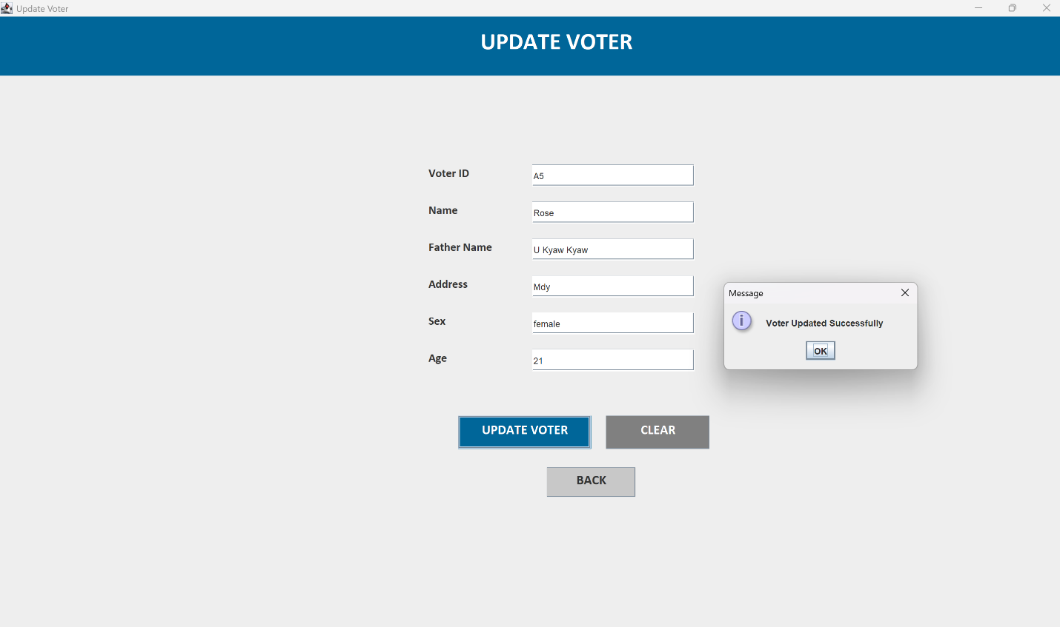

Fig 5.4 Update Voter

5.5 Display Voter
When the admin clicks “Display Voter” from the dashboard, the system shows a list of all registered voters in a table. Each row displays the Voter ID, Father Name, Address, Sex, and Age. The admin can scroll through the list to view voter details.

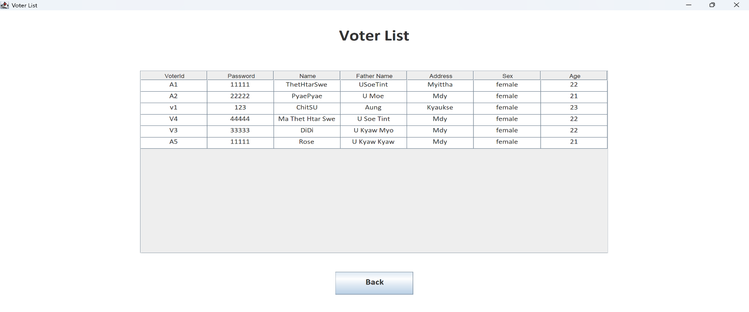

Fig 5.5 Display Voter

5.6 Add Candidate
This page is used by the admin to add new Candidate details into the system.When the admin clicks “Add Candidate” from the dashboard, they arrive at the Add Candidate Page. This page shows a form with fields for Party Name, Party Leader, Sex, Age, Headquarter, and Party Sign. The admin fills in the details and clicks the “Add Candidate” button. The system saves the candidate in the database and shows a confirmation message.
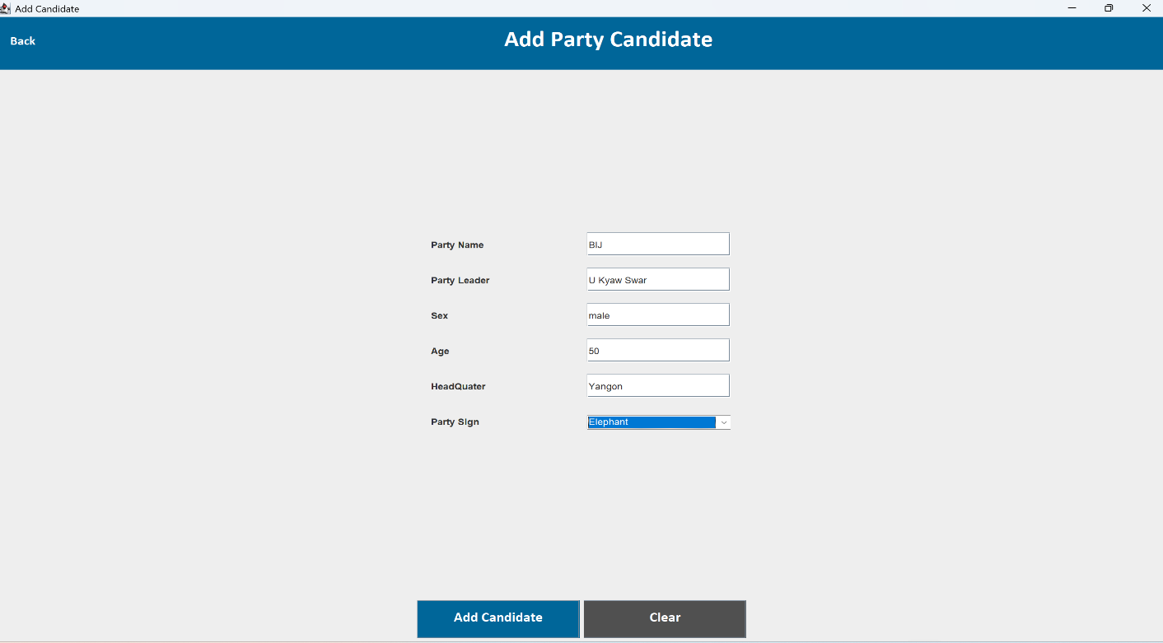
Fig 5.6 Add Candidate

5.7 Update Candidate
This page is used by the admin to update candidate details. When the admin clicks “Update Candidate” from the dashboard, they see a page with a form to search and edit a candidate. The admin enters the Party Name or to load the candidate’s current details. They can then edit Party Leader, Sex, Age, Headquarter, and Party Sign and click “Update Candidate”. The system saves the changes in the database and shows a confirmation message.
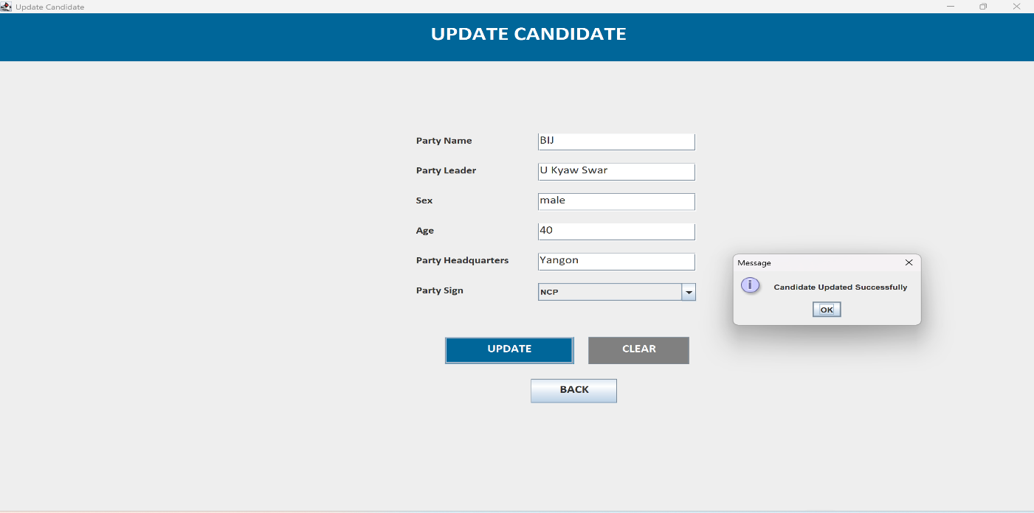

5.7 Update Candidate

5.8 Display Candidate List
When the admin clicks “Display Candidate” from the dashboard, the system shows a list of all registered candidates in a table. Each row displays Party Name, Party Leader, Sex, Age, Headquarter, and Party Sign. The admin can scroll through the list to view candidate details.
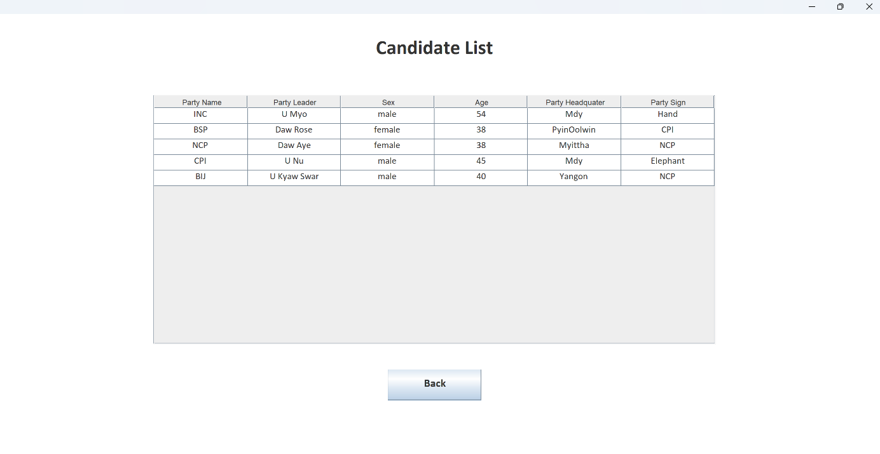

Fig 5.8 Display Candidate List

5.9 Start Counting
When the admin clicks “Start Counting”, the system shows the Candidate List Table with all candidates and a Result Table showing each party’s name and the number of votes it received. The system automatically counts votes from the voters and updates the result table, showing zero if no votes have been cast.
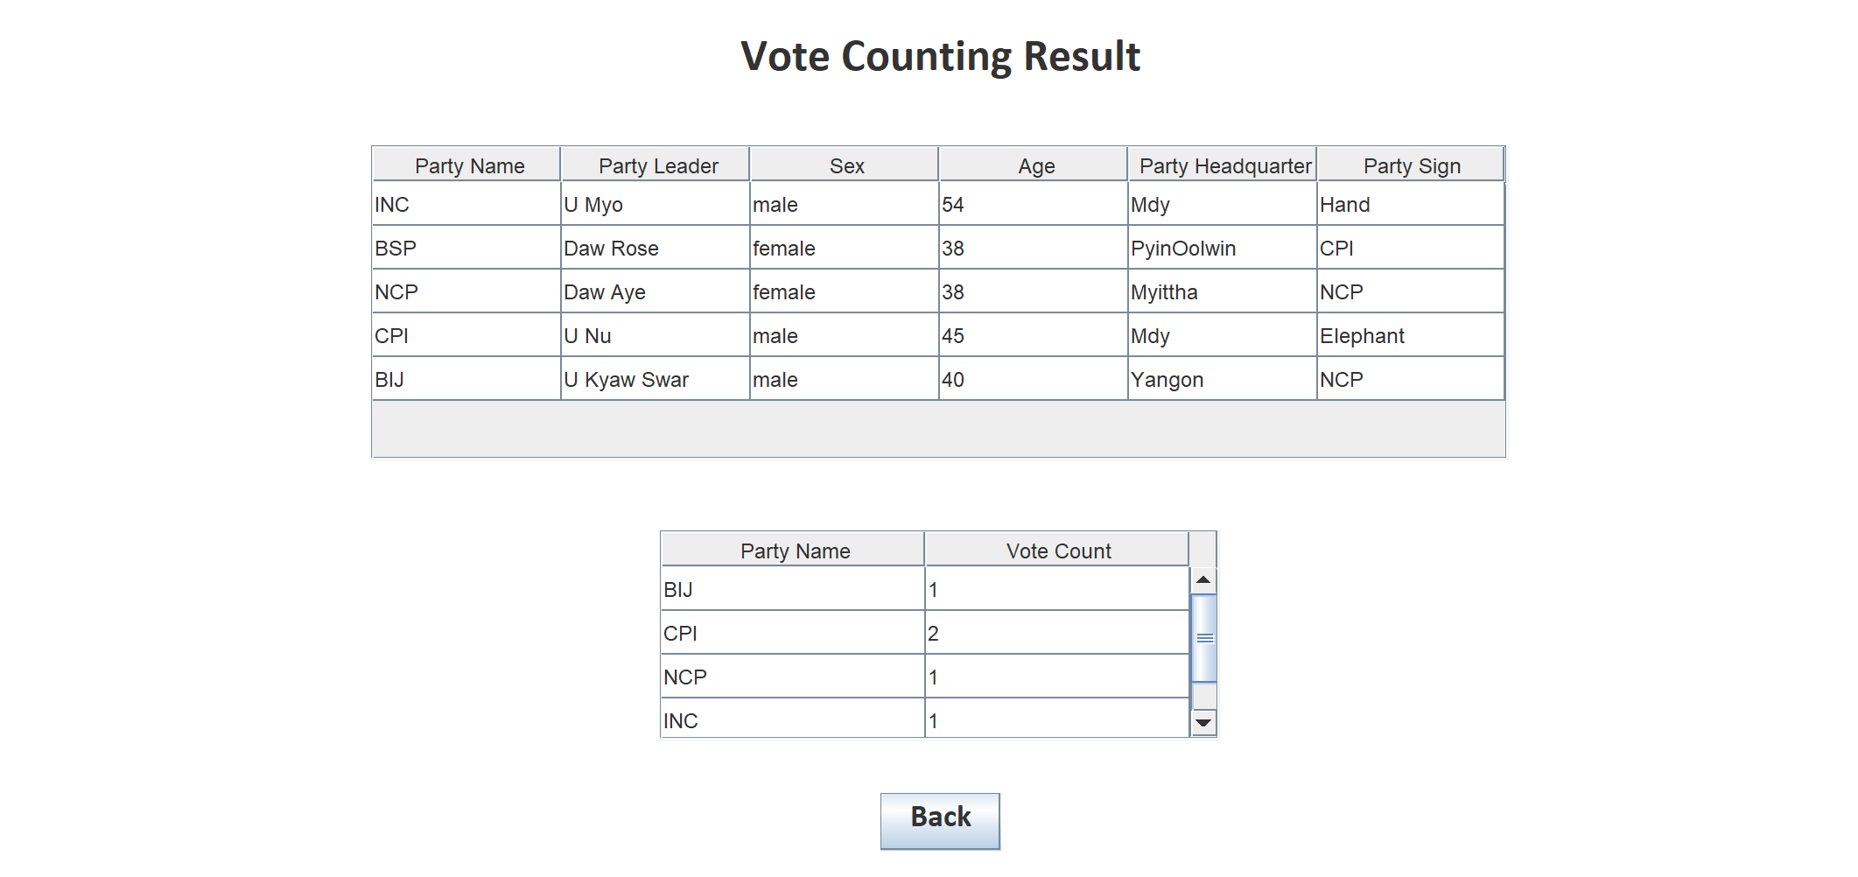

Fig 5.9 Start Counting

5.10 Voter home page
This page allows voters to start the election and select a candidate to cast their vote.

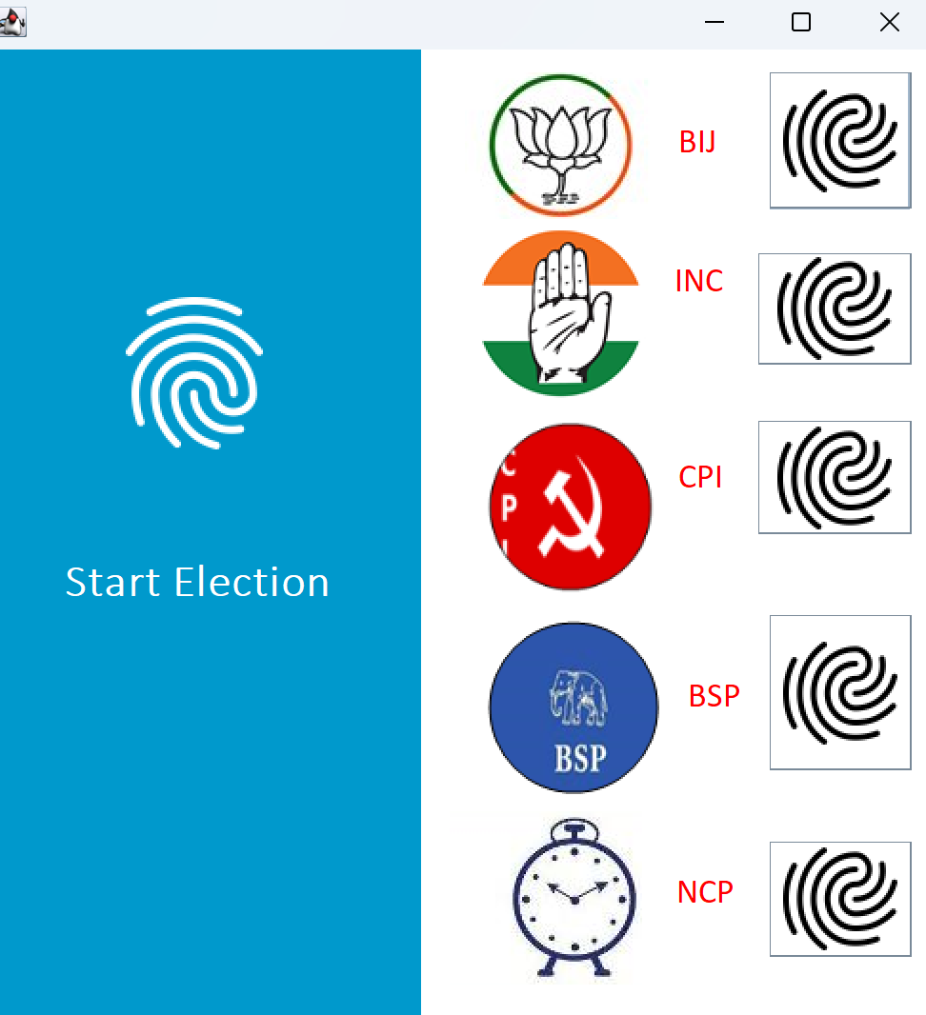

Fig 5.10 Voter home page

5.11 View Result
When the admin clicks “Start Counting”, the system shows the Candidate List Table with all candidates and a Result Table showing each party’s name and the number of votes it received. The system automatically counts votes from the voters and updates the result table, showing zero if no votes have been cast.

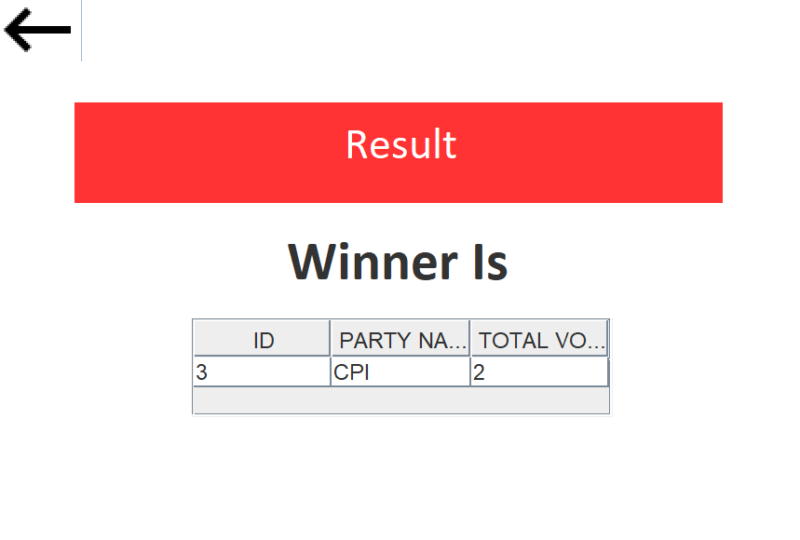

Fig 5.11 View Result

6. Conclusion
The Secure Voting Management System provides a reliable and efficient solution for conducting elections electronically. By replacing traditional paper-based voting methods, the system reduces manual work, minimizes errors, and improves the overall speed and accuracy of the election process.
The system allows administrators to easily manage voter and candidate information, while voters can securely log in and cast their votes through a simple and user-friendly interface. Security features ensure that each voter can vote only once and that all voting data is stored safely in the database. This helps maintain transparency, data integrity, and trust in the election process.
Overall, the Secure Voting Management System demonstrates how technology can simplify election management while ensuring security and accuracy. It provides a practical and effective approach for organizations or institutions that require a secure and automated voting solution. Future improvements can include enhanced security features, web or mobile support, and integration with advanced authentication methods to further improve the system.

